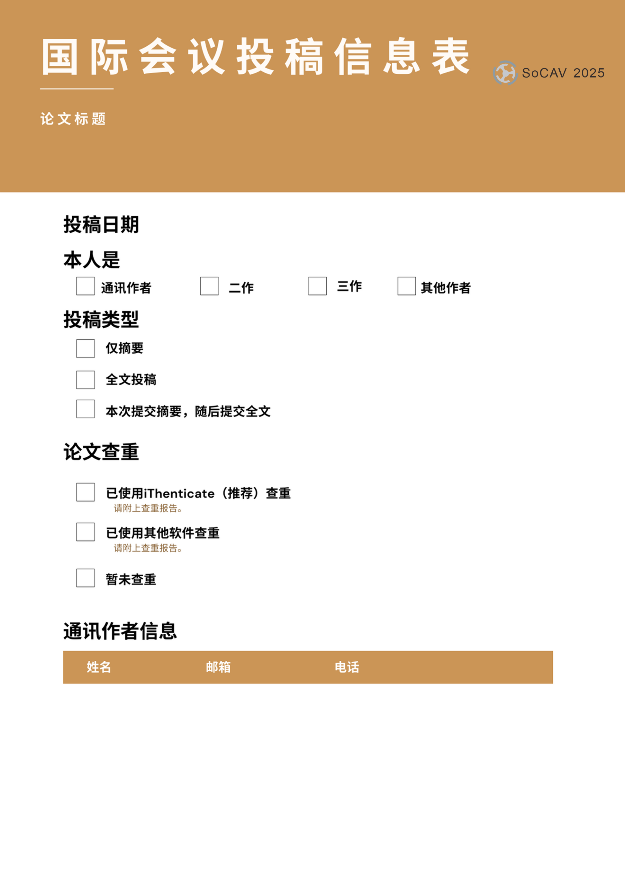

✓

✓

|  |  |  |
| --- | --- | --- |
|  |  |  |

✓

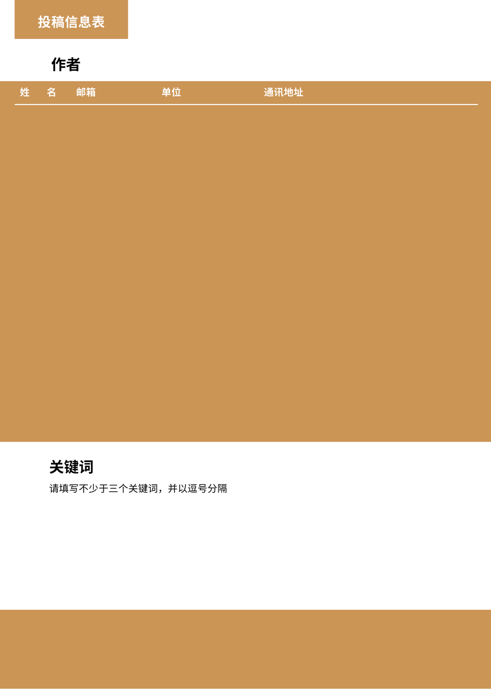

**2025年车联网与自动驾驶车辆国际会议**

徽标

AI 生成的内容可能不正确。

|  |  |  |  |  |
| --- | --- | --- | --- | --- |
|  |  |  |  |  |
|  |  |  |  |  |
|  |  |  |  |  |
|  |  |  |  |  |
|  |  |  |  |  |

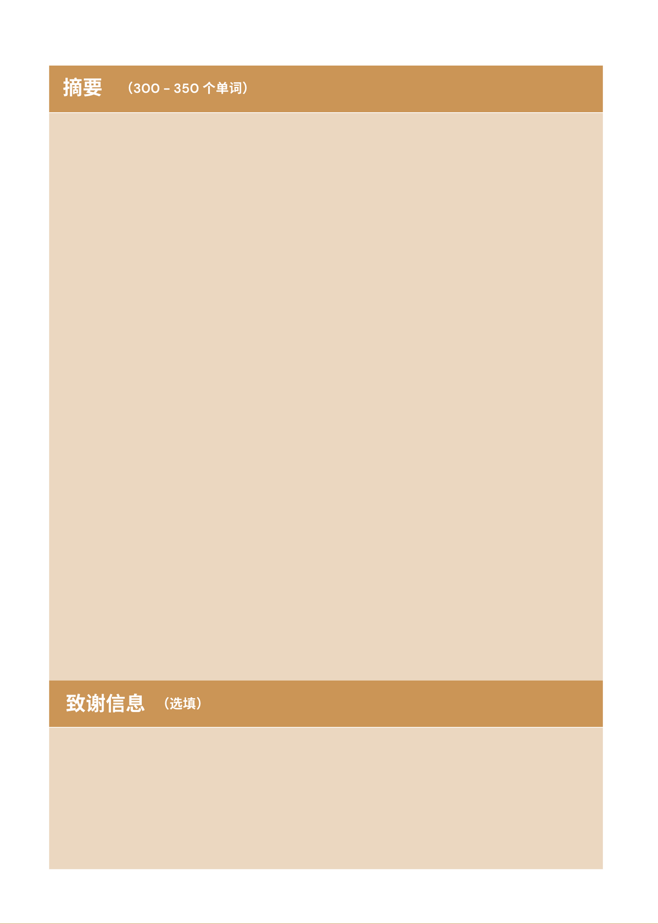

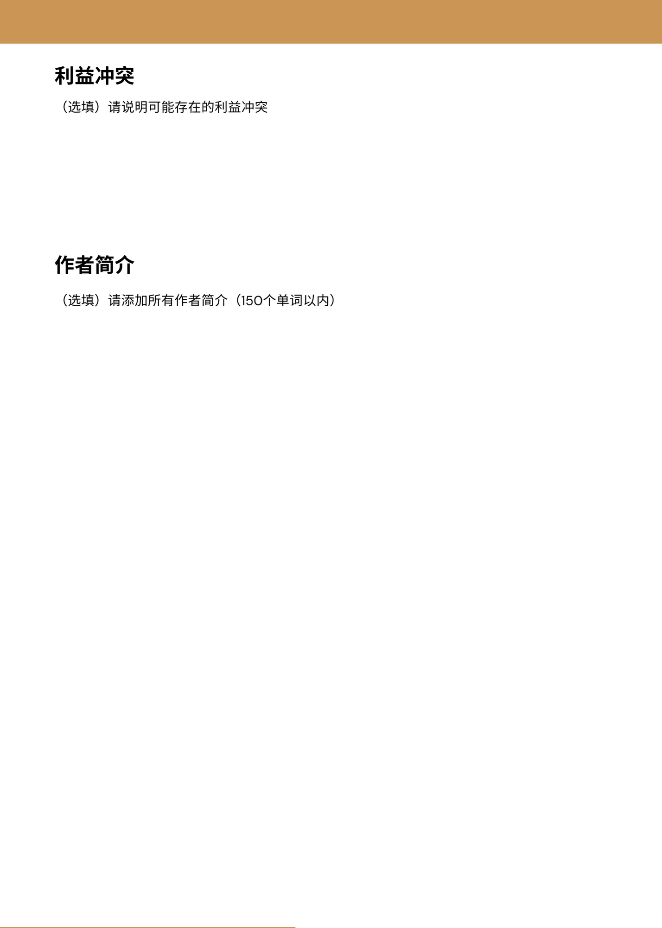

|  |  |
| --- | --- |
| **姓名** | **简介** |
|  |  |
|  |  |
|  |  |
|  |  |
|  |  |

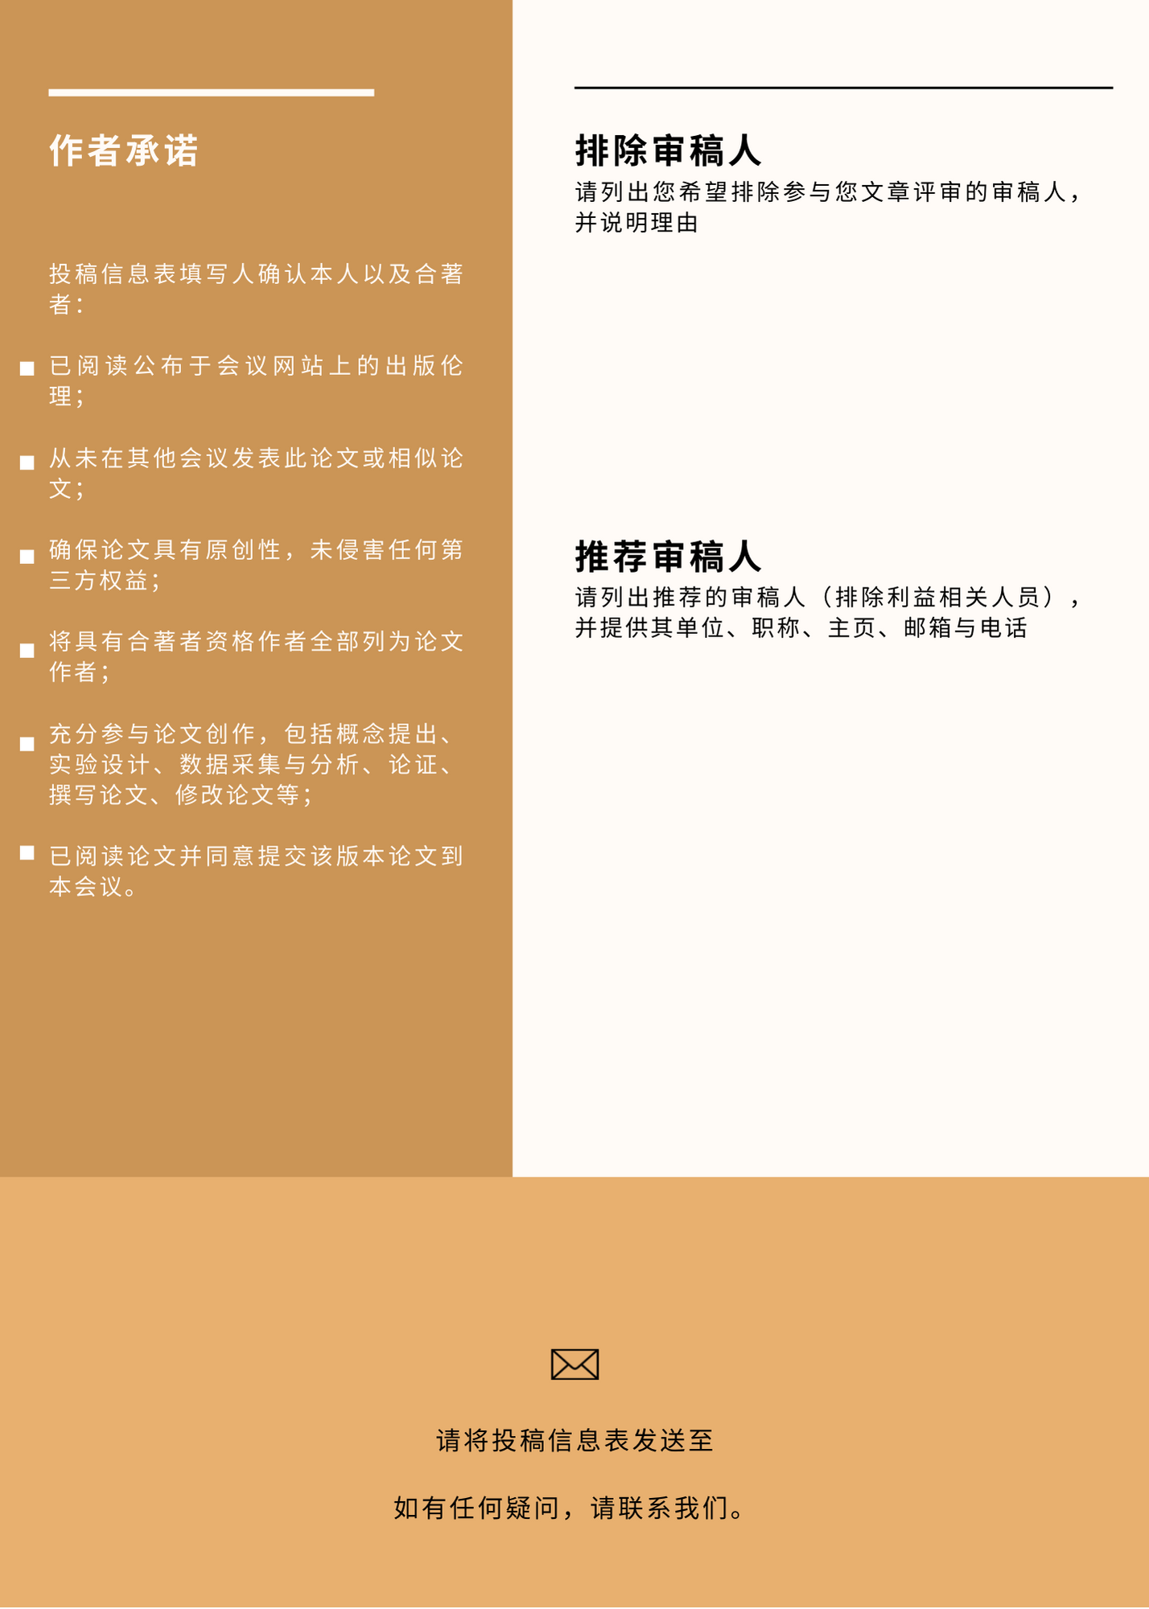

[email@socav.org](mailto:email@socav.org)